**Experiment -14**

Aim: Deploy a static HTML website as container and pushing to Dockerhub

1. Create a file named “Dockerfile” and building image with it

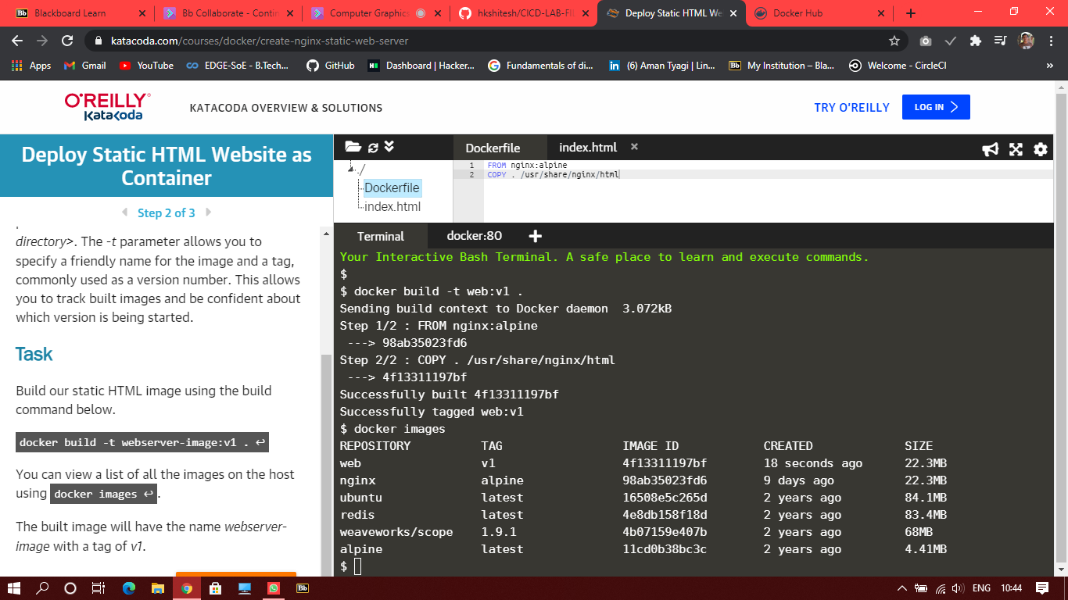

1. Run a container with this image

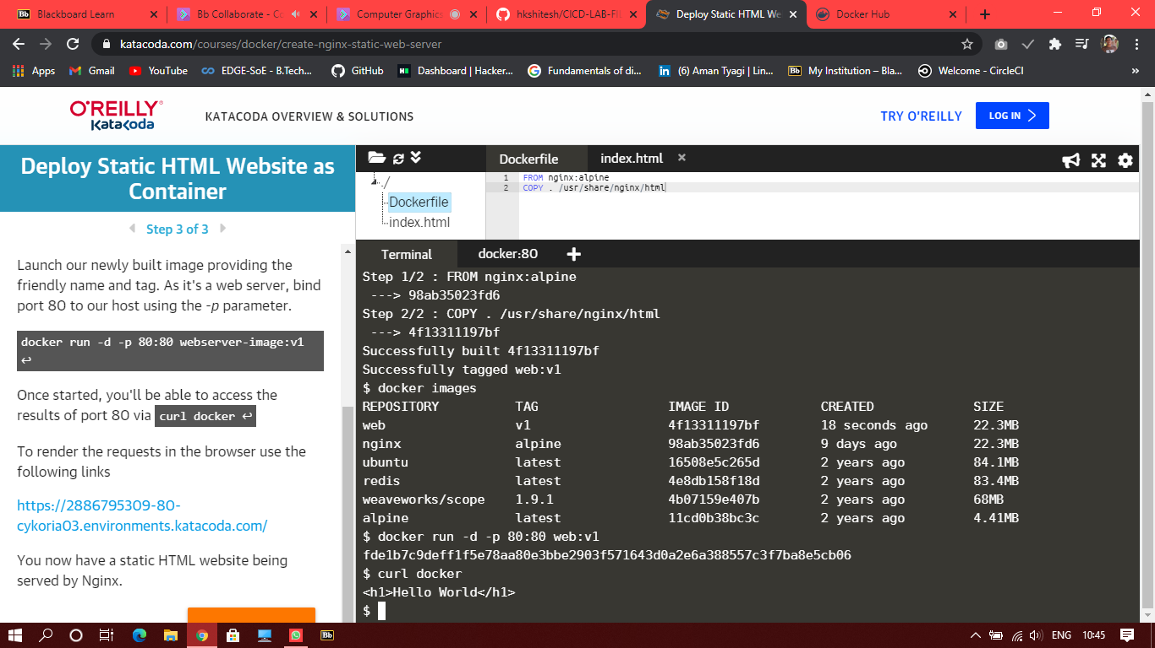

1. Checking the webpage

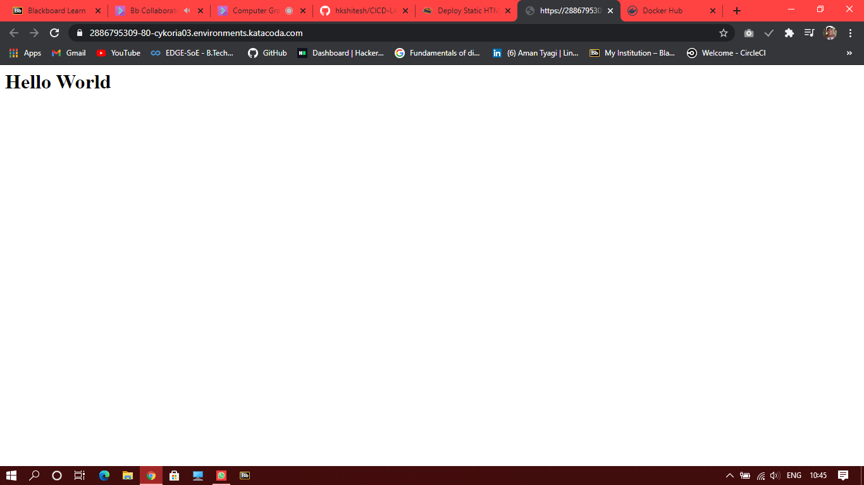

1. Pushing it to Dockerhub

